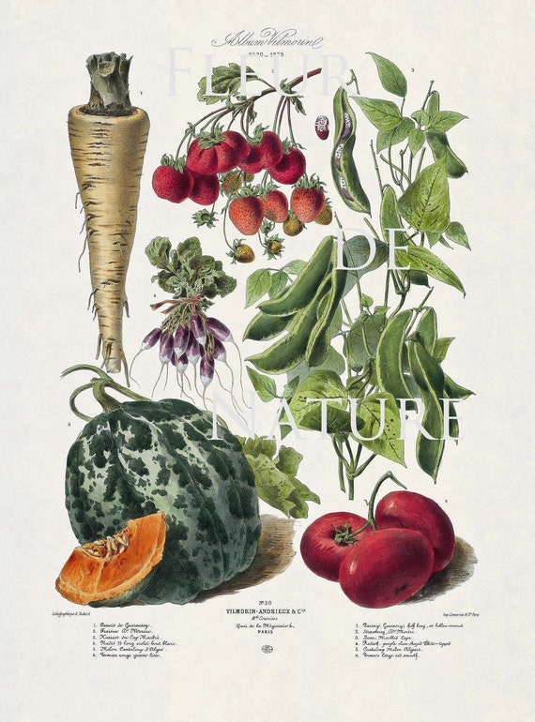
DLH Horticultural Society

Meetings are usually held on the second Friday of the month at 7.30.
Indoor meetings, unless otherwise stated in the Programme are held at:

Florence Nightingale Memorial Hall,
Mill Lane,
Holloway
DE4 5 BD

New members are always welcome. You can download the 2025 Programme from our website.

Enquiries to gardeningdlh@gmail.com
Web site: www.dlhgardening.com

Face book page: Dethick Lea and Holloway Horticultural Society

Dethick Lea & Holloway
Horticultural Society

Annual Horticultural Show
2025

Florence Nightingale Hall
20th September 2025

A celebration of the joys of gardening
and home produce.



PRIZES AND SPONSORS
The Society would like to thank our generous sponsors:
- John Smedley Ltd has given a £50 voucher. This will be awarded to the individual who gains the most points over all classes.
There are 3 family prizes, awarded to the 3 families who accumulate the most points. Double points in children’s categories!
- The Heights of Abraham –voucher valued at £80 (2 adults and 2 children)
- Little Monkeys Play centre voucher -2 child tickets
- Genesis Bowling Centre voucher for one hour’s bowling

Fruit Classes
- Cooking apples, plate of 5
- Eating apples, plate of 5
- Raspberries or blackberries, plate of 12 with stalks
- Pears, plate of 5
- Any other fruit

Home Produce Section
- Jam, one jar any variety
- Lemon Curd, one jar
- Marmalade, one jar
- Honey, one jar clear or set
- Pickles, one jar
- Cucumber relish (recipe on dlhgardening.com)
- Chutney, one jar any variety
- Cake made with a vegetable or fruit ingredient
- Victoria Sponge (recipe on dlhgardening.com)
- Bread cobs 4 white or wholemeal
- Fruit Scones, 4 on a plate (recipe on dlhgardening.com)
- Savoury Scones (recipe on dlhgardening.com )
- Loaf of bread, white or wholemeal
- 6 decorated cupcakes on a plate

Photography Competition
- Wonderful perennials (members only)
- Garden statues, ornaments and water features (members only)
- Garden wildlife (members only)
- My favourite public garden image (OPEN)

The Show Sections
Children’s class (Under 8 and 8-14 years)
- Miniature Garden
- Tallest sunflower (printed photo acceptable)
- Natural picture using petals, leaves, stick frame (printed photo acceptable)
- Vegetable animal
Flower Classes
- Dahlia, 3 blooms, any variety
- Rose, one stem, single bloom or spray
- Bunch of mixed culinary herbs
- Shrub material, berries and seed heads (no flowers) arranged in a vase
- Mixed vase of flowers on a colour theme
- Perennials, one spike of a single variety
- Perennials, one vase of three stems of different varieties
- Hydrangea, one stem with bloom
Vegetable Classes
- Potatoes, any variety, plate of 5
- Onions, plate of 3
- Carrots, bunch of 3
- Shallots, plate of 5
- Runner beans, plate of 6
- Beetroot, 3
- Lettuce, with washed roots
- Cucumber, one
- Tomatoes, small, 7 on a plate
- Tomatoes, large, 5 on a plate, any variety
- Courgette, plate of 3
- Cabbage, 1 with washed roots
- Any other vegetable
- Comedy vegetable
- Longest runner bean (members only)

Fruit classes
- Cooking apples, plate of 5
- Eating apples, plate of 5
- Plums, plate of 6
- Raspberries or blackberries, plate of 12 with stalks
- Any other fruit

Home produce section
- Jam, one jar any variety
- Jelly, one jar any variety
- Lemon Curd, one jar
- Marmalade, one jar
- Honey, one jar clear or set
- Pickles, one jar
- Chutney, one jar any variety
- Cake made with a vegetable or fruit ingredient
- Victoria Sponge
- Bread cobs 6 white or wholemeal
- Scones, 6 on a plate fruit or savoury
- Loaf of bread, white or wholemeal
- Celebratory cupcakes, six on a plate
- Any other sweet cakes e.g. Patisserie

Art
- An art work on the theme of Harvest

Photography (DLHHS members only)
- Garden flowers
- Fruit and vegetables
- Garden wildlife
- My wild garden


Programme

- Staging of exhibits : 10.00 - 11.30pm.
Entry & Staging of Exhibits is FREE.

- Judging the Exhibits : 12 - 2pm.
Hall closed

- Show open to public : 2 - 4pm.
Light refreshments available.
Items not to be auctioned to be removed by 3pm

- Auction of Produce. 3.15 – 3.45pm
Close – 4pm.



