Dethick, Lea and Holloway Horticultural Society

Friday 10th October at 7.30pm

Florence Nightingale Memorial Hall, Holloway.

“An Evening of Floral Inspiration from an Autumn Garden”
with Jonathan Mosley
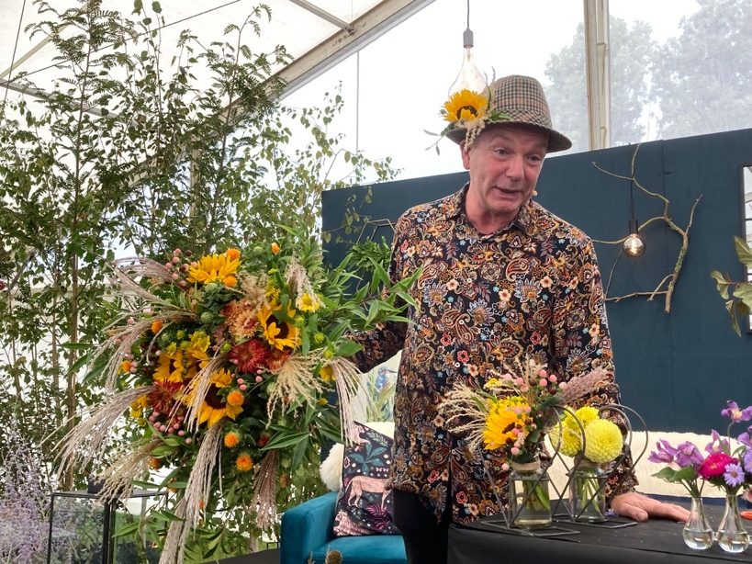
Jonathan is an internationally celebrated floral designer. Known for his hugely engaging RHS demonstrations, teaching and broadcasting as well as his stunning floral bridge at 1st RHS
Chatsworth Show

We are delighted to welcome Jonathan to Holloway to demonstrate three autumn arrangements in his highly entertaining manner! With stories and plenty of down-to-earth advice, this promises to be a most enjoyable evening. The flower arrangements will be raffled at the end of the evening.
For this special meeting, entry is by pre-booked ticket only.
Strictly limited.
Members are free but need to book a ticket, non-members £5. To book or purchase a ticket please contact Carol Brown via email: carolbrown05@btinternet.com or call 07717 572668

Scan QR code to visit
Jonathan’s website.

